**VISVESVARAYA TECHNOLOGICAL UNIVERSITY**

**JNANA SANGAMA, BELAGAVI – 590 018, KARNATAKA**

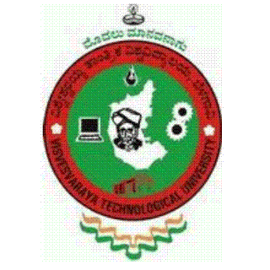

**Technical Seminar Report on**

**“Natural Language Tool Kit”**

*Submitted in partial fulfilment for the award of degree of*

**BACHELOR OF ENGINEERING**

**IN**

**COMPUTER SCIENCE AND ENGINEERING**

***Submitted By***

**Naveen Pandurangi**

**[ 1VK15CS034]**

**Under the Guidance of**

**Prof. Chandramma R**

**Assoc. Professor, Dept. of CSE,**

**VKIT, Bengaluru.**

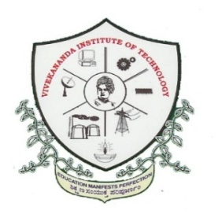

**Janatha Education Society®**

**DEPARTMENT OF COMPUTER SCIENCE AND ENGINEERING**

**VIVEKANANDA INSTITUTE OF TECHNOLOGY**

**GUDIMAVU, KUMBALAGODU POST, KENGERI HOBLI, BENGALURU –560 074**

**2018-2019**